Database Documentation

Step One: Create a Database
- Navigate to your online integrated development environment (IDE). List and record the SQL commands that you used to complete this step here:
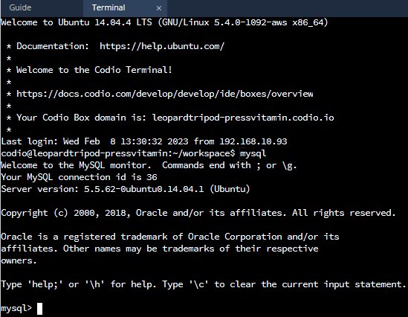
mysql
- Create a database schema called QuantigrationUpdates. List out the database name. Provide the SQL commands you ran against MySQL to successfully complete this in your answer:
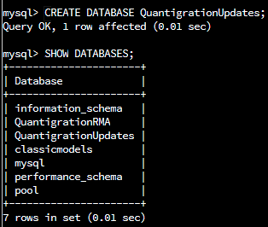
CREATE DATABASES; SHOW DATABASES;
- Using the entity relationship diagram (ERD) as a reference, create the following tables with the appropriate attributes and keys:
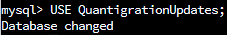
  - A table named Customers in the QuantigrationUpdates database, as defined on the project ERD. Provide the SQL commands you ran against MySQL to complete this successfully in your answer:
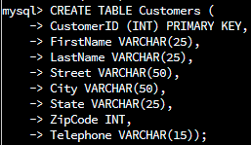
  - A table named Orders in the QuantigrationUpdates database, as defined on the project ERD. Provide the SQL commands you ran against MySQL to complete this successfully in your answer:
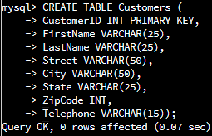
  - A table named RMA in the QuantigrationUpdates database, as defined on the project ERD. Provide the SQL commands you ran against MySQL to complete this successfully in your answer:
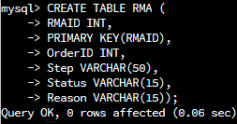

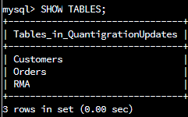

Step Two: Load and Query the Data
- Import the data from each file into tables.
  - Use the QuantigrationUpdates database, the three tables you created, and the three CSV files preloaded into Codio.
  - Use the import utility of your database program to load the data from each file into the table of the same name. You will perform this step three times, once for each table.
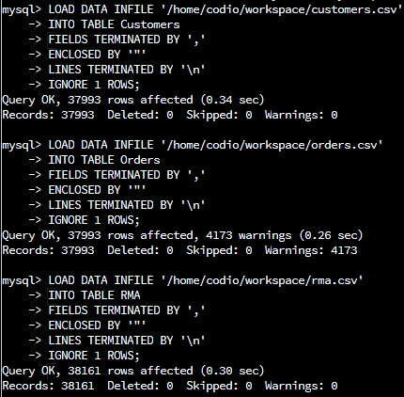
- Write basic queries against imported tables to organize and analyze targeted data. For each query, replace the bracketed text with a screenshot of the query and its output. You should also include a 1- to 3-sentence description of the output.
  - Write an SQL query that returns the count of orders for customers located only in the city of Framingham, Massachusetts.
    - How many records were returned?
505 records returned from this query:
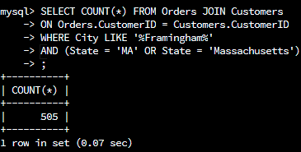
  - Write an SQL query to select all of the Customers located in the state of Massachusetts.
    - Use a WHERE clause to limit the number of records in the Customers table to only those who are located in Massachusetts.
    - Record an answer to the following question: How many records were returned?
982 returned records (customers) returned from this query:
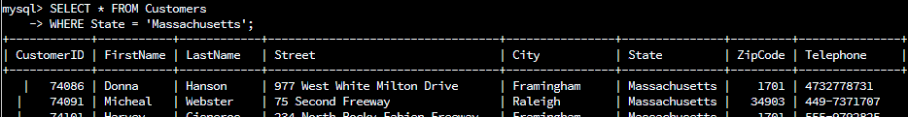$…$
SELECT * FROM Customers
WHERE State = ‘Massachusetts’;

  - Write a SQL query to insert four new records into the Orders and Customers tables using the following data:
Customers Table

CustomerID | FirstName | LastName | Street | City | State | ZipCode | Telephone
100004 | Luke | Skywalker | 15 Maiden Lane | New York | NY | 10222 | 212-555-1234
100005 | Winston | Smith | 123 Sycamore Street | Greensboro | NC | 27401 | 919-555-6623
100006 | MaryAnne | Jenkins | 1 Coconut Way | Jupiter | FL | 33458 | 321-555-8907
100007 | Janet | Williams | 55 Redondo Beach Blvd | Torrence | CA | 90501 | 310-555-5678

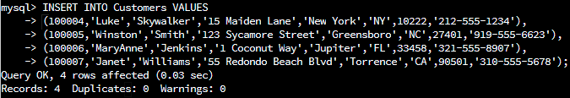

Orders Table

OrderID | CustomerID | SKU | Description
1204305 | 100004 | ADV-24-10C | Advanced Switch 10GigE Copper 24 port
1204306 | 100005 | ADV-48-10F | Advanced Switch 10 GigE Copper/Fiber 44 port copper 4 port fiber
1204307 | 100006 | ENT-24-10F | Enterprise Switch 10GigE SFP+ 24 Port
1204308 | 100007 | ENT-48-10F | Enterprise Switch 10GigE SFP+ 48 port
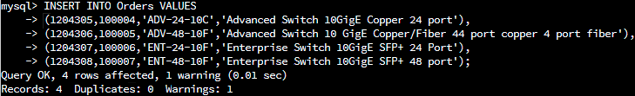

  - In the Customers table, perform a query to count all records where the city is Woonsocket, Rhode Island.
    - How many records are in the Customers table where the field “city” equals “Woonsocket”?
7 records returned from this query:
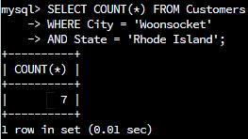

  - In the RMA database, update a customer’s records.
    - Write an SQL statement to select the current fields of status and step for the record in the RMA table with an orderid value of “5175.”
      - What are the current status and step?
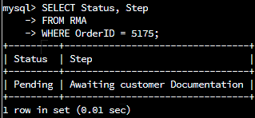
Status = ‘Pending’
Step = ‘Awaiting customer Documentation’
    - Write an SQL statement to update the status and step for the OrderID, 5175 to status = “Complete” and step = “Credit Customer Account.”
      - What are the updated status and step values for this record?

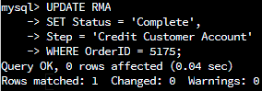
Status = ‘Complete’
Step = ‘Credit Customer Account’
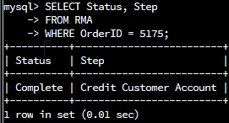
  - Delete RMA records.
    - Write an SQL statement to delete all records with a reason of “Rejected.”
      - How many records were deleted?
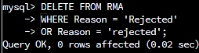

595 records deleted from this query.
- Update your existing tables from “Customer” to “Collaborator” using SQL based on this change in requirements. Provide the SQL commands you ran against MySQL to complete this successfully in your answer:
  - Rename all instances of “Customer” to “Collaborator.”
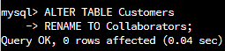

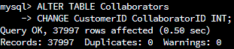

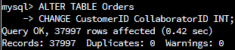
- Create an output file of the required query results. Write an SQL statement to list the contents of the Orders table and send the output to a file that has a .csv extension.

